Tgl Implementation Notes

Tgl, Thin Graphics Layer, is an attempt to provide a common interface to various 3D renderers. In other words, Tgl provides an abstraction of a 3D renderer. Tgl is implemented in C++.

Goals

Renderer Independence
The primary purpose of Tgl is to provide a renderer independent interface. It should be possible to implement Tgl drivers for various renderers.

Platform Independence
Tgl should be portable to various window systems, operating systems and hardware platforms.

Thin
Tgl is by design intended to be a thin layer to an underlying renderer and to provide a direct pipeline to the renderer. Tgl is not intended to maintain the state of the renderer and does not provide a pipeline from the renderer. Thus, Tgl cannot be used to query about Tgl objects or underlying renderer objects - e.g. Tgl does not provide any GetParent() or EnumerateObjects() functionality; a client must maintain its own data structures to support such functionality, if needed.

Status
Currently, there are Tgl drivers for Reality Lab 2.0 and DirectX 2.
It is expected that the Tgl interface will need to evolve and be modified when Tgl drivers are implemented for other renderers.
The exact interface to various platforms window systems has not been finalized. Currently, Tgl requires DirectDraw.

Tgl Interface
Tgl is provided in form of an abstract C++ interface. The abstract interface of Tgl is provided in the namespace Tgl and consists of 9 classes (Object, Renderer, Device, View, Camera, Light, Group, Mesh, Texture) and 1 global function (CreateRenderer()).

namespace Tgl
{
class Object { … };
class Renderer : public Object { … };
class Device : public Object { … };
class View : public Object { … };
class Camera : public Object { … };
class Light : public Object { … };
class Group : public Object { … };
class Mesh : public Object { … };
class Texture : public Object { … };
Renderer* CreateRenderer();
}

Reference Counting
Tgl objects are references (or handles) to underlying renderer objects, see Figure 1.

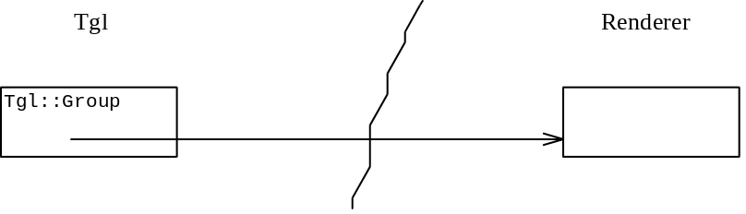
Figure 1

The underlying renderer objects are reference counted. The reference count starts out as 1 when the object is first created. When, e.g. a mesh is added into a group, mesh’s reference count is increased. When the mesh is removed from the group, mesh’s reference count is decreased. When the reference count reaches zero the underlying renderer object is deleted.
A Tgl object that refers to an underlying renderer object causes the underlying renderer object’s reference count to increase. Thus, it is important to properly delete Tgl objects in order for the underlying renderer objects to be deleted.

Renderer* pRenderer = CreateRenderer();
View* pView = pRenderer->CreateView(…);
Group* pParent;
Group* pChild ;

pParent = pRenderer->CreateGroup(); // parent’s reference count == 1
pChild = pRenderer->CreateGroup(); // child’s reference count == 1
// see Figure 2

pParent->Add(pChild); // child’s reference count == 2
// see Figure 3

delete pChild; // child’s reference count == 1
// see Figure 4

pView->Render(pParent); // render parent (and its child)

delete pParent; // parent’s reference count == 0
// underlying renderer object will be deleted,
// causing child’s reference count go to 0,
// and thus child will be deleted

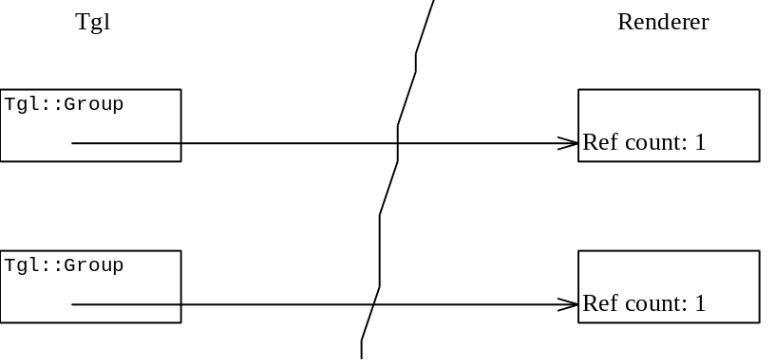
Figure 2

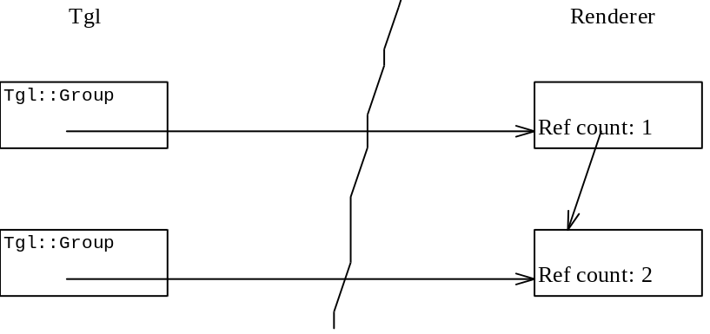
Figure 3: after pParent->Add(pChild)

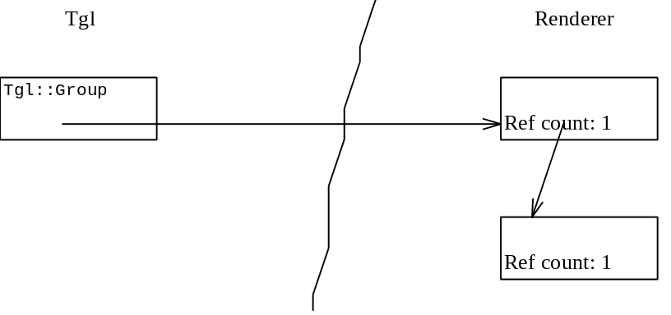
Figure 4: after delete pChild

Tgl Drivers
A Tgl driver is an implementation of Tgl for a specific renderer (e.g. DirectX 2).
To provide a Tgl driver you must implement each of the abstract Tgl classes and an the global function Tgl::CreateRenderer(). This is done by deriving from each of the abstract classes, implementing all their pure virtual member functions, and implementing Tgl::CreateRenderer() to create an instance of the specific renderer.

Tgl Implementation Templates
The Tgl implementation templates (TglImpl) derives from each of the abstract Tgl classes and implement all of their pure virtual functions. They are thus able to provide Tgl driver implementations. Of course, these templates don’t know anything about any specific renderer but expects the renderer specific details to be specified in the template argument. The template argument should be a driver struct, a struct, which defines various type names and static member functions. Note, there is no driver struct object at runtime - the information needed is extracted out of the driver struct at compile time.

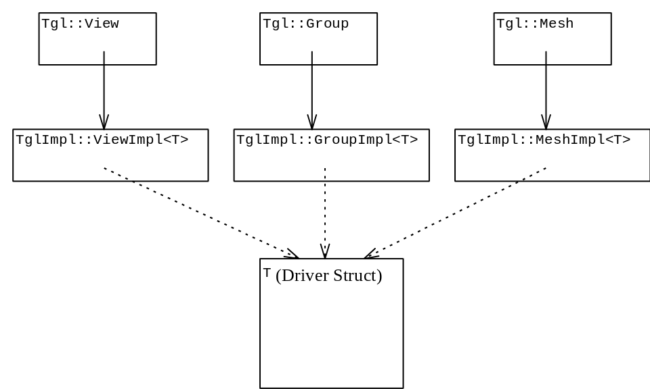
Figure 5

TglImpl is mostly typesafe. TglImpl classes introduces data members to hold references to the underlying renderer objects. These data members are not void* or any other generic type, but correctly typed using the underlying renderer’s data types. The only potential problem with typesafety is in the abstract interface. TglImpl must downcast pointers to Tgl objects to pointers to TglImpl objects. This can be a problem only if a client uses more than one kind of renderer in an application, and passes a Tgl object created by one renderer to another renderer.
The Tgl implementation templates are provided in the namespace TglImpl using the naming convention of appending Impl to the abstract Tgl class name.

namespace TglImpl
{
using namespace Tgl;
template <class T> class RendererImpl : public Renderer { … };
template <class T> class DeviceImpl : public Device { … };
template <class T> class ViewImpl : public View { … };
template <class T> class CameraImpl : public Camera { … };
template <class T> class LightImpl : public Light { … };
template <class T> class GroupImpl : public Group { … };
template <class T> class MeshImpl : public Mesh { … };
template <class T> class TextureImpl : public Texture { … };
}

In addition to implement Tgl’s pure virtual functions, TglImpl’s parameterized classes define additional member functions. These member functions make up a concrete Tgl interface. A client can bypass the abstract Tgl interface and use the concrete interface in an almost renderer independent way as described below.
There are several benefits with the TglImpl: it allows for code sharing - TglImpl do a fair amount of error checking and all classes instantiated from these templates will get this for free; it provides a systematic way of implementing a driver - you provide the implementation of a driver struct, a struct containing the renderer specific details; it allows for usage of concrete Tgl classes - maybe the most important benefit.
In summary, the Tgl implementation templates in conjunction with a driver struct is one way of implementing a Tgl driver. Of course, a Tgl driver can also be implemented by simply deriving directly from the abstract Tgl classes.

Driver Struct
A driver struct is a struct containing details about a specific renderer. TglImpl defines the requirements of this structure. For example, the struct must define 8 type names used by TglImpl for data members to hold the underlying renderer object. Furthermore, the struct must also define a number of static member functions that are used by TglImpl.
Most of the driver struct member functions should be inline - this in conjunction with inlining of key template functions allow for maximum performance.

struct D3DRM
{
typedef IDirect3DRM* RendererDataType;
…
};
RendererImpl<D3DRM> g_theD3DRMRenderer;

Abstract Interface
A client uses the abstract Tgl interface by calling CreateRenderer() to create a renderer. The renderer is the factory of all other objects; Renderer has various member functions to create the other Tgl objects, Device, View, Group etc. The kind of renderer (Reality Lab 2.0, DirectX 2 etc.) returned by CreateRenderer() is determined by which Tgl driver is linked with the client. Although it would be possible for a client to use two different kinds of renderers concurrently, by linking with two Tgl drivers, there is currently no abstract interface to specify which kind of renderer to create.
Note, that the abstract interface does expose a hook to get to the underlying renderer object through Tgl::Object::ImplementationDataPtr(), which returns a pointer to the data member holding the native renderer data.

Advantages
- By using the abstract interface there is no need to recompile an application to switch to another kind of Tgl driver. There are no dependencies on an underlying renderer compiled into the application. The application only needs to be re-linked with a different Tgl driver. Even the re-link can be avoided if the application dynamically loads the desired Tgl driver.

Disadvantages
- All Tgl objects created using the abstract interface will be heap allocated. The Tgl objects are very small, typically 8 bytes including the vtable pointer.
- Since the Tgl objects are heap allocated, they must be deallocated explicitly.
- All calls to Tgl objects are virtual calls.

Example

class LOD : public LODObject
{
...
Tgl::Group* m_pMeshGroup;
};

LOD::LOD(Tgl::Renderer* pRenderer)
{
float vertices[][3] = { ... };
float textureCoordinates[][2] = { ... };
unsigned long faces[] = { ... };
int vertexCount = ...;
int faceCount = ...;
Tgl::Mesh* pMesh;

m_pMeshGroup = pRenderer->CreateGroup(0);
pMesh = pRenderer->CreateMesh(vertexCount,
vertices,
textureCoordinates,
faceCount,
vertixPerFaceCount,
faces);
m_pMeshGroup->Add(pMesh);
delete pMesh;
}

LOD::~LOD()
{
delete m_pMeshGroup;
}

Concrete Interface
A client uses the concrete Tgl interface by using the TglImpl classes. Rather than having the renderer allocate the Tgl objects on the heap, the client can allocate TglImpl objects on the stack or as data members of other objects. The client can then use both the abstract Tgl interface and the concrete TglImpl member functions.
When a TglImpl object is created you must specify which kind of renderer is being used by specifying the driver struct, e.g. RendererImpl<RL20>. However, using proper typedefs you can avoid the scattering of the specific renderer in the source files to allow for easy switching to a different renderer.

#ifdef USE_D3DRM

#include "tglRL40.h"
typedef TglImpl::RendererImpl<D3DRMImpl::D3DRM> TglRenderer;
typedef TglImpl::DeviceImpl<D3DRMImpl::D3DRM> TglDevice;
typedef TglImpl::ViewImpl<D3DRMImpl::D3DRM> TglView;
typedef TglImpl::GroupImpl<D3DRMImpl::D3DRM> TglGroup;
typedef TglImpl::LightImpl<D3DRMImpl::D3DRM> TglLight;
typedef TglImpl::CameraImpl<D3DRMImpl::D3DRM> TglCamera;
typedef TglImpl::TextureImpl<D3DRMImpl::D3DRM> TglTexture;
typedef TglImpl::MeshImpl<D3DRMImpl::D3DRM> TglMesh;

#elif USE_RL20

#include "tglRL20.h"
typedef TglImpl::RendererImpl<RL20Impl::RL20> TglRenderer;
typedef TglImpl::DeviceImpl<RL20Impl::RL20> TglDevice;
typedef TglImpl::ViewImpl<RL20Impl::RL20> TglView;
typedef TglImpl::GroupImpl<RL20Impl::RL20> TglGroup;
typedef TglImpl::LightImpl<RL20Impl::RL20> TglLight;
typedef TglImpl::CameraImpl<RL20Impl::RL20> TglCamera;
typedef TglImpl::TextureImpl<RL20Impl::RL20> TglTexture;
typedef TglImpl::MeshImpl<RL20Impl::RL20> TglMesh;

#else

#error Unknown Tgl driver

#endif

Advantages
- Since a client controls the allocation of concrete Tgl objects they can be allocated on the stack or as data members within other objects. They need not be heap allocated.
- Concrete Tgl objects are automatically destructed when they go out of scope.
- Calls to concrete TglImpl member functions are inline non-virtual calls.

Disadvantages
- A client that uses concrete Tgl objects is compiled with a specific driver struct. To switch to use a different renderer the whole application needs to be re-compiled with a different driver struct.

Example

class LOD : public LODObject
{
...
TglGroup m_meshGroup;
};

LOD::LOD(TglRenderer& rRenderer)
{
float vertices[][3] = { ... };
float textureCoordinates[][2] = { ... };
unsigned long faces[] = { ... };
int vertexCount = ...;
int faceCount = ...;
TglMesh mesh;

rRenderer.CreateGroup(0, m_meshGroup);
rRenderer.CreateMesh(mesh,
vertexCount,
vertices,
textureCoordinates,
faceCount,
vertixPerFaceCount,
faces);
m_meshGroup.Add(mesh);
}

LOD::~LOD()
{
}

Tgl Implementation
Tgl is provided in tgl.h and tglVector.h. All names introduced by Tgl is in the namespace Tgl.

TglImpl Implementation
TglImpl is provided in tglImpl.h. All names introduced by TglImpl is in the namespace TglImpl.
Each TglImpl class implements all the pure virtual functions of the corresponding Tgl class. Additionally, a TglImpl class introduces a concrete interface. The concrete interface consists of a default constructor, Destroy(), ImplementationData(), and a member function for each abstract member function that takes pointers to other abstract classes.
All TglImpl classes are implemented using same strategy, and below follows a discussion of a typical class, GroupImpl.

template <class T>
class GroupImpl : public Group
{
public:
GroupImpl() : m_data(0) {}
~GroupImpl();

private:
GroupImpl(const GroupImpl<T>&);
GroupImpl<T>& operator=(const GroupImpl<T>&);

public:

// Object members
void* ImplementationDataPtr();

// Group members
Result SetTransformation(const DoubleMatrix4&);
Result SetColor(double, double, double);
Result SetTexture(const Texture*);
Result Add(const Mesh*);
Result Add(const Group*);
Result Remove(const Group*);
Result Remove(const Mesh*);
Result RemoveAll();

// Concrete Data Type Interface
void Destroy();
Result SetTexture(const TextureImpl<T>*);
Result Add(const GroupImpl<T>&);
Result Add(const MeshImpl<T>&);
Result Remove(const GroupImpl<T>&);
Result Remove(const MeshImpl<T>&);
T::GroupDataType& ImplementationData();
const T::GroupDataType& ImplementationData() const;

private:
T::GroupDataType m_data;
};

Remember, when a client uses the abstract interface, the client calls Renderer::CreateGroup() to create a Group. The implementation of Renderer::CreateGroup(), (namely RendererImpl<T>::CreateGroup()) will create a GroupImpl<T> object on the heap. When the group is no longer used, the client calls delete to dispose of it.
When a client uses the concrete TglImpl classes, the client itself creates a GroupImpl<T>. Then, the client calls the concrete RendererImpl<T>::CreateGroup() to create the underlying renderer object.
First thing to note is that GroupImpl implements all of Tgl::Group’s pure virtual functions.
Secondly, note the data member m_data. TglImpl classes uses this member to hold the underlying renderer object. The type of m_data is determined by the driver struct, specified as template argument, and is a native data type that is used by the underlying renderer.
Thirdly, note the concrete interface. It is very similar to the abstract interface, but takes references to concrete objects, instead of pointers to abstract interfaces. As is described below, the implementation of the abstract interface uses the concrete interface.

template <class T>
inline
void
GroupImpl<T>::Destroy()
{
if (m_data)
{
T::GroupDestroy(m_data);
m_data = 0;
}
}

The concrete Destroy()member should be called when the group is no longer used and the underlying renderer object should be deleted. However, the underlying renderer object is not deleted until its reference count reaches zero. Clients using the concrete interface normally do not need to call Destroy(), as the destructor, GroupImpl<T>::~GroupImpl() calls Destroy() automatically.

template <class T>
Result
GroupImpl<T>::Add(const Mesh* pMesh)
{
assert(m_data);
assert(pMesh);

return Add(*static_cast<const MeshImpl<T>*>(pMesh));
}

This is the implementation of the abstract Tgl::Add() member. It simply delegates to the concrete GroupImpl<T>::Add() to perform the real work.

template <class T>
inline
Result
GroupImpl<T>::Add(const MeshImpl<T>& rMesh)
{
assert(m_data);
assert(rMesh.ImplementationData());

return T::GroupAddMesh(m_data, rMesh.ImplementationData());
}

This is the implementation of the concrete Tgl::Add() member. The abstract Add() takes a pointer to an abstract class Tgl::Mesh, while the concrete Add() takes a reference to a concrete class TglImpl::MeshImpl<T>. The concrete Add() delegates to the driver struct T::GroupAddMesh() to perform the real work. Note, that the concrete Add() member is inline, and if the driver struct’s T::GroupAddMesh()is also defined inline, clients using the concrete interface will have minimum overhead, if any, compared to writing towards the native renderer API.
Also note, how all parameters to driver struct member functions take only driver specific data types. In this way, the driver struct can be implemented completely using renderer native data types.

Driver Struct Implementation
Driver structs are defined in tgl<Driver Struct Name>.h. E.g., the Reality Lab 2.0 driver struct is defined in tglRL20.h.
TglImpl defines the requirements on the driver struct, the type being used as parameter for the instantiations of the TglImpl classes (e.g. RL20). First, the type must provide 8 types (or typedefs) to be used to hold references to the underlying renderer’s data structures. Secondly, the type must provide implementations of numerous static members that in effect implements the Tgl functionality. These static members can, and should, be implemented as inline member function for optimal performance.

struct <driver struct name>
{
typedef <renderer native renderer data type> RendererDataType;
typedef <renderer native device data type> DeviceDataType;
typedef <renderer native view data type> ViewDataType;
typedef <renderer native camera data type> CameraDataType;
typedef <renderer native light data type> LightDataType;
typedef <renderer native group data type> GroupDataType;
typedef <renderer native mesh data type> MeshDataType;
typedef <renderer native texture data type> TextureDataType;

// Renderer
static Result RendererCreate(RendererDataType&);
static void RendererDestroy(RendererDataType);
static Result RendererCreateDevice(RendererDataType,
const DeviceDirectDrawCreateData&,
DeviceDataType&);
static Result RendererCreateDevice(RendererDataType,
const DeviceDirect3DCreateData&,
DeviceDataType&);
static Result RendererCreateView(RendererDataType,
DeviceDataType,
CameraDataType camera,
unsigned long x,
unsigned long y,
unsigned long width,
unsigned long height,
ViewDataType&);
static Result RendererCreateCamera(RendererDataType, CameraDataType&);
static Result RendererCreateLight(RendererDataType,
LightType,
double r, double g, double b,
LightDataType&);
static Result RendererCreateGroup(RendererDataType,
GroupDataType parentGroup,
GroupDataType&);
static Result RendererCreateMesh(RendererDataType,
unsigned long vertexCount,
const float (*pVertices)[3],
const float (*pTextureCoordinates)[2],
unsigned long faceCount,
unsigned long vertexPerFaceCount,
unsigned long* pFaceData,
MeshDataType&);
static Result RendererCreateMesh(RendererDataType,
unsigned long vertexCount,
const float (*pVertices)[3],
const float (*pTextureCoordinates)[2],
unsigned long* pFaceData,
MeshDataType&);
static Result RendererCreateTexture(RendererDataType,
TextureDataType&);
static Result RendererCreateTexture(RendererDataType,
int width, int height,
int bitsPerTexel,
const void* pTexels,
int pTexelsArePersistent,
int paletteEntryCount,
const PaletteEntry*,
TextureDataType&);

static Result RendererSetTextureDefaultShadeCount(RendererDataType,
unsigned long);
static Result RendererSetTextureDefaultColorCount(RendererDataType,
unsigned long);

// Device
static void DeviceDestroy(DeviceDataType);
static Result DeviceSetColorModel(DeviceDataType, ColorModel);
static Result DeviceSetShadingModel(DeviceDataType, ShadingModel);
static Result DeviceSetShadeCount(DeviceDataType, unsigned long);
static Result DeviceSetDither(DeviceDataType, int);
static unsigned long DeviceGetWidth(DeviceDataType);
static unsigned long DeviceGetHeight(DeviceDataType);
static void DeviceHandleActivate(DeviceDataType, int);
static void DeviceHandlePaint(DeviceDataType, void* pData);
static Result DeviceUpdate(DeviceDataType);
#ifdef _DEBUG
static unsigned long DeviceGetDrawnTriangleCount(DeviceDataType);
#endif

// View
static void ViewDestroy(ViewDataType);
static Result ViewClear(ViewDataType);
static Result ViewSetCamera(ViewDataType, CameraDataType);
static Result ViewAddLight(ViewDataType, LightDataType);
static Result ViewRemoveLight(ViewDataType, LightDataType);
static Result ViewRender(ViewDataType, GroupDataType);
static Result ViewForceUpdate(ViewDataType,
unsigned long x,
unsigned long y,
unsigned long width,
unsigned long height);
static Result ViewSetBackgroundColor(ViewDataType,
double r, double g, double b);
static Result ViewSetProjection(ViewDataType, ProjectionType);
static Result ViewSetFrontClippingPlane(ViewDataType, double distance);
static Result ViewSetBackClippingPlane(ViewDataType, double distance);
static Result ViewSetFrustrum(ViewDataType,
double frontClippingDistance,
double backClippingDistance,
double degrees);
static Result ViewPick(ViewDataType,
unsigned long x,
unsigned long y,
const TglImpl::GroupImpl<driver struct name>** ppGroups,
int groupsToPickFromCount,
const Group**& rppPickedGroups,
int& rPickedGroupCount);
static Result ViewTransformWorldToScreen(ViewDataType,
const double world[3],
double screen[4]);

// Camera
static void CameraDestroy(CameraDataType);
static Result CameraSetTransformation(CameraDataType, const DoubleMatrix4&);

// Light
static void LightDestroy(LightDataType);
static Result LightSetTransformation(LightDataType, const DoubleMatrix4&);

// Group
static void GroupDestroy(GroupDataType);
static Result GroupSetTransformation(GroupDataType, const DoubleMatrix4&);
static Result GroupSetColor(GroupDataType, double r, double g, double b);
static Result GroupSetTexture(GroupDataType, TextureDataType);
static Result GroupAddGroup(GroupDataType, GroupDataType childGroup);
static Result GroupAddMesh(GroupDataType, MeshDataType);
static Result GroupRemoveGroup(GroupDataType, GroupDataType childGroup);
static Result GroupRemoveMesh(GroupDataType, MeshDataType);
static Result GroupRemoveAll(GroupDataType);
static Result GroupTransformLocalToWorld(GroupDataType,
const double local[3],
double world[3]);
// Mesh
static void MeshDestroy(MeshDataType);
static Result MeshSetColor(MeshDataType,
double r, double g, double b);
static Result MeshSetTexture(MeshDataType, TextureDataType);
static Result MeshSetTextureMappingMode(MeshDataType,
TextureMappingMode);
static Result MeshSetShadingModel(MeshDataType, ShadingModel);
#ifdef _DEBUG
static Result MeshGetBoundingBox(MeshDataType, float[3], float[3]);
static unsigned long MeshGetFaceCount(MeshDataType);
static unsigned long MeshGetVertexCount(MeshDataType);
#endif

// Texture
static void TextureDestroy(TextureDataType);
static Result TextureSetTexels(TextureDataType,
int width, int height,
int bitsPerTexel,
const void* pTexels,
int pixelsArePersistent);
static Result TextureSetPalette(TextureDataType,
int entryCount,
const PaletteEntry*);
};

Drivers
Tgl drivers are provided in tgl<Driver Struct Name>.lib, using the source file tgl<Driver Struct Name>.cpp. E.g., the Reality Lab 2.0 driver is provided in tglRL20.lib using the source file tglRL20.cpp.
Once the driver struct has been defined and implemented for a specific renderer it is a simple matter to implement the driver. All that is needed is to implement Tgl::CreateRenderer(), which can be implemented as:

namespace Tgl
{
Renderer* CreateRenderer()
{
TglImpl::RendererImpl<RL20Impl::RL20>* pRenderer;

pRenderer = new TglImpl::RendererImpl<RL20Impl::RL20>;
if (!pRenderer->Create())
{
delete pRenderer;
pRenderer = 0;
}

assert(pRenderer);
return pRenderer;
}
} // namespace Tgl

The TglImpl templates automatically generates the rest of the code.

